A few notes concerning the 3 channel current amplifier.

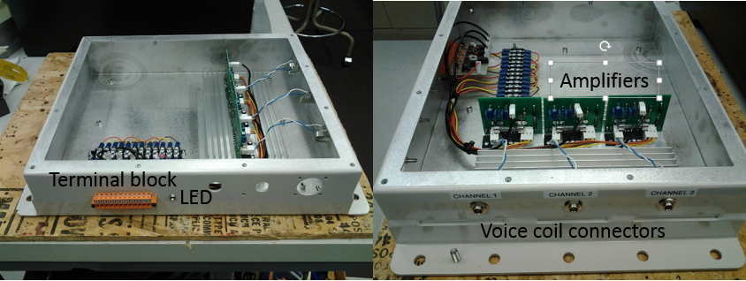
Figure 1: Amplifier with lid removed. This doesn’t show power supplies that are now included in the unit..
There is a 12 section terminal block mounted on the face of the enclosure. Here are the terminal block designations.
1: Plus 15 Volts DC output.
2: Common.
3: Negative 15 Volts DC output.
4: Channel 1 input.
5: Channel 1 common.
6: Channel 2 input.
7: Channel 2 common.
8: Channel 3 input.
9: Channel 3 common.
10: Plus 3.3 Volts DC input from MyRio 3.3 Volts source on the MPX Port. (this is needed to enable the voice coil amplifier)
11: Digital input. Connect to one of the Digital Ports on the MPX Port.
12: Digital GND. Connect to any of the DGND terminals of the MPX Port.
The +/- 15 volt power supply is rated for at least 3 amps in order to have all three amplifiers work to their full specification.
Inside the amplifier box is a 3 channel circuit that converts the 0 to 5 Volts of the MPX Port Digital to Analog output to a +/- 10 volts signal that goes to the current amplifiers. The main purpose of this converter circuit is to allow the amplifier to output a bi-polar signal for driving the Voice Coil Actuators in both directions. Thus from a LabView programming point of view, 0 volts equates to -10 Volts or -1 amp to move the Voice Coil Actuators in the negative direction. 2.5 Volts converts to 0 volts or 0 amps to the Voice Coil Actuators to put it in it’s midpoint. 5 volts converts to +10 volts or +1 amp to move the Voice Coil Actuators in the positive direction.
The main reason there is a digital input to the current amplifier box is to allow the LabView program to enable and disable the current amplifiers independently of the output voltage of the digital to analog ports of the MPX Port. This is necessary because the default output voltage if the digital to analog ports is 0 volts. Thus in your LabView program you must set the output of the digital to analog ports to 2.5 Volts before you use a digital port to enable the amplifiers.
The default output of the digital ports is high. Thus the digital input of the amplifier box is “Active Low”. To the right of the terminal block is an LED that lights up when the digital input to the amplifier is low and the amplifiers are activated. You may use any digital channel of your choice.
On the short side of the enclosure are three ¼” phone jacks. These are “stereo” type jacks that you plug in a stereo plug. The three provided stereo cables have one end stripped and tined for soldering to the Voice Coil Actuators. The WHITE wire connects the “positive” terminal wire of the Voice Coil Actuator and the RED wire is the “negative” that connects to the “negative” wire of the Voice Coil Actuator. The shield wire of the cable is not connected to anything.
The MyRio interface boards are just terminal block connected to the 34 pin edge connectors of the MPX ports. There are two 12 position terminal blocks and one 10 position terminal block. The numerical labeling of the three terminal blocks corresponds to the 34 pin connector on the MyRIO ports A and B as shown below.

